For Loop Lab-7

Name: Kaushik Parmar

ID: AF0448761

1. 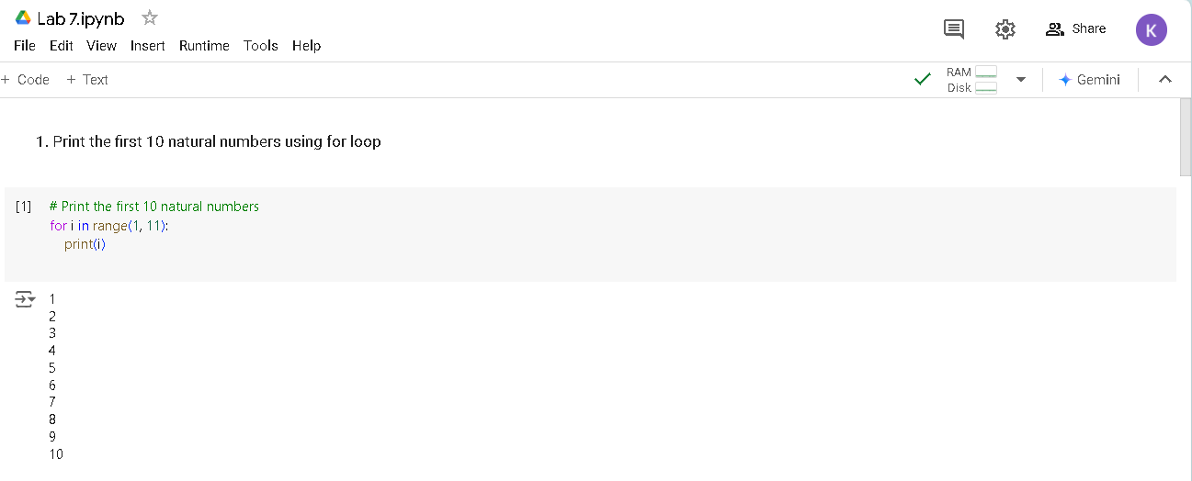Print the first 10 natural numbers using for loop
2. 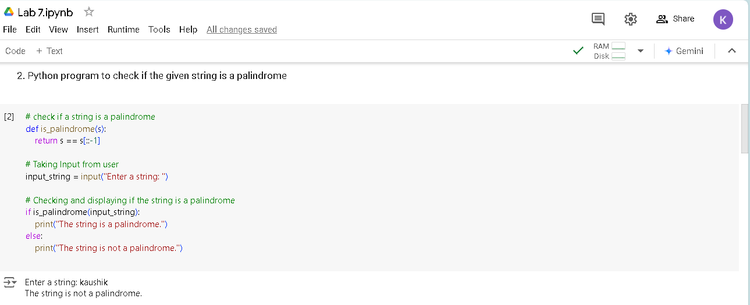Python program to check if the given string is a palindrome

1. 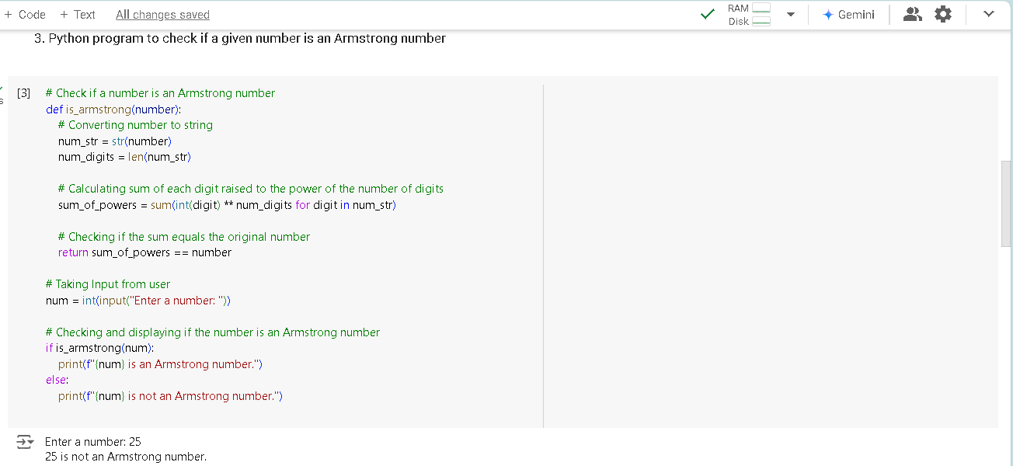Python program to check if a given number is an Armstrong number
2. Python program to get the Fibonacci series between 0 to 50 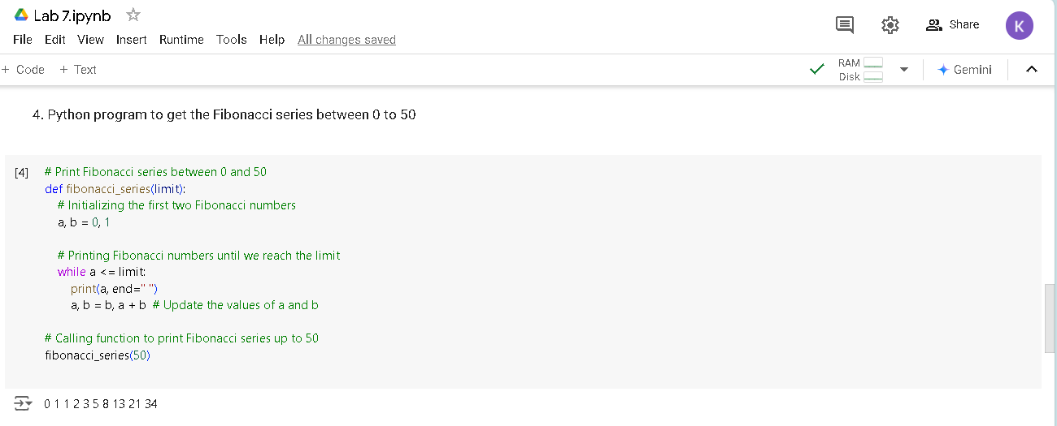

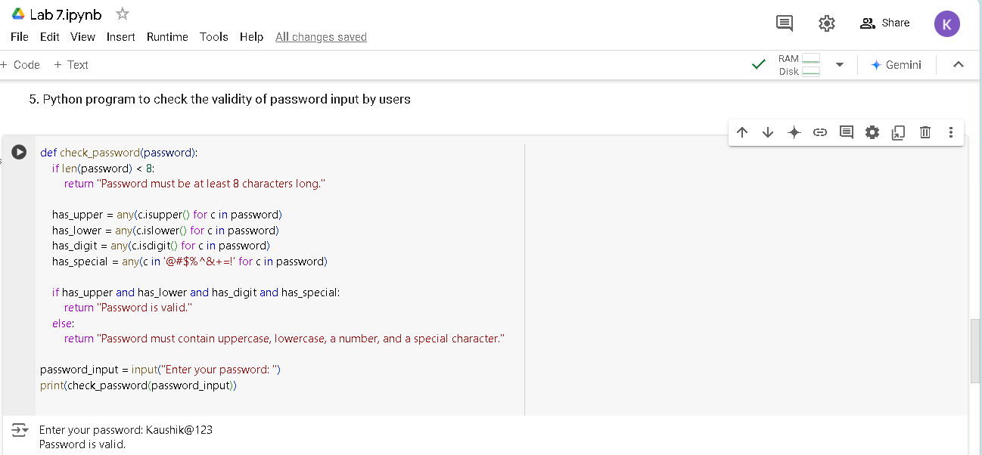5. Python program to check the validity of password input by users